**APPENDIX I. Preparation of Parameters for Green & Ampt Loss Method**

1. Download GitHub repository from <https://github.com/prasanna310/SSURGO_Extract_ArcGIS/archive/master.zip>
2. Unzip the folder
3. Open Python script named “*Extract_SSURGO.py”*

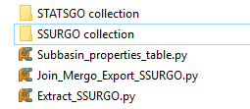

1. Run the python script (twice), replacing the highlighted portion with the value for path2collectionOfssurgoFolders as “SSURGO collection”, and “STATSGO collection”. This produces a text file with soil values for each map units.

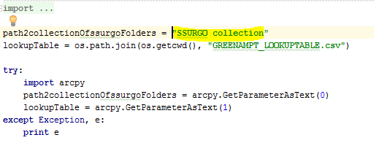

The results looks something like this.

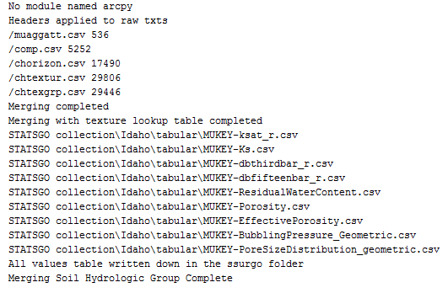

1. Add the ArcGIS toolbox (according to the version of ArcGIS installed on the computer) to ArcGIS

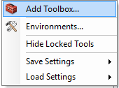

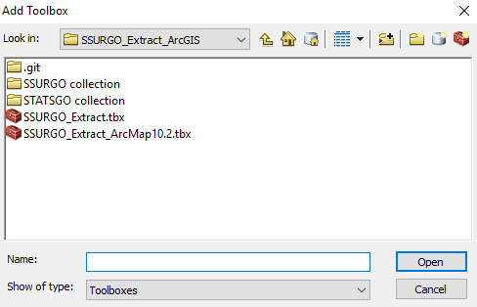

1. Run the script named “Step2_Join, Merge and Export” from the ArcGIS.

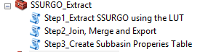

Fill in the input parameters, similar to the ones done in the example below, and the Match Raster is the AgreeDEM or other raster that represent the area. STATSGO and the SSURGO folders are present in the GitHub repository downloaded earlier in the tutorials.

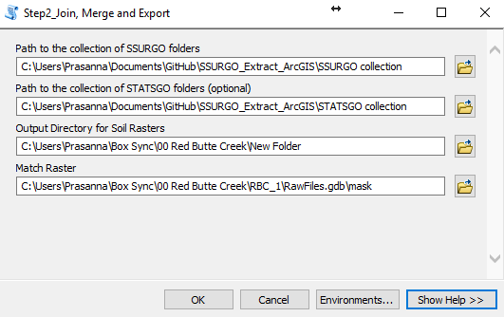

This script creates raster files (tiffs) for the area representing different soil properties such as effective porosity, suction pressure, poresize distribution, hydrologic soil group etc.

1. Run the Script named “Create Subbasin Properties Table”. The TIF folder represents the path where the raster files (TIF) representing soil properties are. Earlier in the tutorial in the STEP 6, the tiff files were created in the folder mentioned. Make this path same to that.

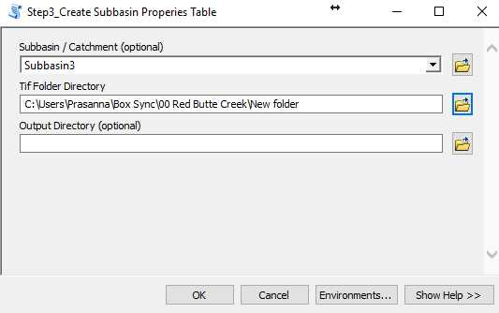

This will result in the creation of Excel file named “Subbasin_characteristics.xls” as shown.

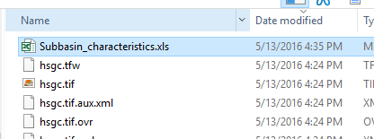

This file contains many unnecessary data fields. For our purpose delete / hide the unnecessary fields until the worksheet looks like this:

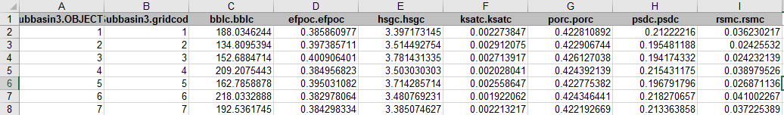

Information about fields/columns:

**Bblc.Bblc** = bubbling pressure or suction head (mm)

**Efpoc.Efpoc** = Effective porosity

**Ksatc.Ksatc** = Saturated Hydraulic conductivity (in mm/s)

**Psdc.Psdc** = pore size distribution

**Rsmc.Rsmc** = Residual Soil Moisture content

These values needed to be added to each subbasin (identified by gridcode) into HEC-HMS

SUMMARY:

1. Download GitHub repository from <https://github.com/prasanna310/SSURGO_Extract_ArcGIS/archive/master.zip>
2. Unzip
3. Open Python script named “*Extract_SSURGO.py”*
4. Run the python script (twice), replacing the highlighted portion with the value for path2collectionOfssurgoFolders as “SSURGO collection”, and “STATSGO collection”. This produces a text file with soil values for each map units.
5. Add the ArcGIS toolbox (according to the version of ArcGIS installed on the computer) to ArcGIS
6. Run the script named “Step2_Join, Merge and Export” from the ArcGIS. Make sure the Match Raster is the AgreeDEM or other raster that represent the area.
7. Run the Script named “Create Subbasin Properties Table”